**WORKSHEET 2**

**PYTHON**

# Q1 to Q8 have only one correct answer. Choose the correct option to answer your question.

1. Which of the following is not a core datatype in python?
   1. list B) struct

C) tuple C) set

**Ans: B) struct**

1. Which of the following is an invalid variable name in python?
   1. _init_ B) no_1

C) 1_no D) _1

**Ans: C) 1_no**

1. Which one of the following is a keyword in python?
   1. in B) _init_

C) on D) foo

**Ans: A) in**

1. In which of the following manner are the operators of the same precedence executed in python?
   1. Left to Right B) BODMAS

C) Right to Left D) None of these

**Ans: A) Left to Right**

1. Arrange the following in decreasing order of the precedence when they appear in an expression in python?

i) Multiplication ii) Division iii) Exponential iv) Parentheses

A) iii – iv – ii – i B) iii – iv – i – ii

C) iv – iii – ii – i D) iii – ii – i – iv

**Ans: C) iv-iii-ii-i**

6. (28//6)**3/3%3 = ?

A) 7.1111… B) 0

C) 0.3333… D) 1

**Ans: C) 0.3333…**

Which of the following is not equal to x16 ?

A) x**4**4 B) x**16

C) x^16 D) (x**4)**4

**Ans:**

1. a = input(“Enter an integer”). What will be the data type of a?
   1. int B) str

C) float D) double

**Ans: B) str**

# Q9 and Q10 have multiple correct answers. Choose all the correct options to answer your question.

1. Which of the following statements are correct?
   1. Division and multiplication have same precedence in python
   2. Python’s operators’ precedence is based on PEDMAS
   3. Python’s operators’ precedence is based on VBODMAS
   4. In case of operators’ having same precedence, the one on the left side is executed first.

**Ans: A) Division and multiplication have same precedence in python**

**B) Python’s operators’ precedence is based on PEDMAS**

1. Which of the following is(are) valid statement(s) in python?

A) abc = 1,000,000 B) a b c = 1000 2000 3000

C) a,b,c = 1000, 2000, 3000 D) a_b_c = 1,000,000

**Ans: A) abc = 1,000,000 C) a,b,c = 1000, 2000, 3000 D) a_b_c = 1,000,000**

# Q11 to Q13 are subjective questions, answer them briefly

1. Differentiate between a list, tuple, set and dictionary.

**List:**

* It is a data structure that holds order collection of items. A list is created by placing all the items inside a square bracket ‘ [ ] ’or using ‘list()’ .
* Any number of items and items of any datatypes can be placed inside a list.
* Example:

A = [ ]

b = [1,2,’Omni’]

x=list((3,4,5))

* A list can have another list within it and it’s called as nested list.
* Slice operator can be used to access the list items.
* List are mutable which means the list can be updated after creation. It is done with the help of slicing.
* append() and extend() methods are used to add items or nested list at the end of the list respectively.
* We can also perform alter(),pop(),remove(),count(),reverse() like methods on the list to manipulate the items.

**Tuple:**

* Like array a tuple can be created by placing items inside brackets ( ).
* It can hold any number of items of different datatypes.
* Example:

A=(1,2,3,5,”pigeon”)

* Using slice operation, the elements can be located
* The tuple is immutable in nature, once created can’t be changed
* count(),index() like methods can be used with tuple.

**Set:**

* It is an unordered collection of data without any index and any duplicated values.
* A set can be created by putting items inside an curly bracket {} or by set().
* Example;

a=set((1122,3234))

b= {12, 23, 45, 67}

* As it has no index so its items can’t be accessed.
* New single item can be add to set by add() method and to add a number of items update() method is used where the items to be updated are used by placing them inside a list.
* Items can be removed or deleted by using remove() and discard() method.

**Dictionary:**

* A Dictionary is an unordered collection of data.
* It stores data inform of key:value pair.
* A dictionary can be formed by placing key:value pairs inside curly brackets or using dict() method.
* Example;

car= {'brand':'', 'Pagani', ‘Speed’:380, 'class':’exotic’}

* Keys of the dictionary should be unique by providing same keys the older key value will be over written by new one.
* To access the value inside an dictionary the key is passed
* The values of the dictionary can be updated
* A new pair of key values can be added to the dictionary.
* keys(),items(),values() are used to access the items inside the dictionary.

1. Are strings mutable in python? Suppose you have a string “I+Love+Python”, write a small code to replace ‘+’ with space in python.

Strings are array in python. Any character in python is a string. Strings are immutable just like array and tuples. We can’t update an existing value of a string or delete them but using inbuilt del keyword entire string can be deleted.

The elements of the strings can be accessed by slicing and indexing, elements can be replaced using replace() method. It generates a copy of the string with the new replaced items.

Here we have a string given and we have to replace the “+” with “ ”. Below is the code line,

In [1]: X=“I+Love+Python”

X.replace(“+”, “ ”)

In [2]: X

Out[2]: 'I Love Python'

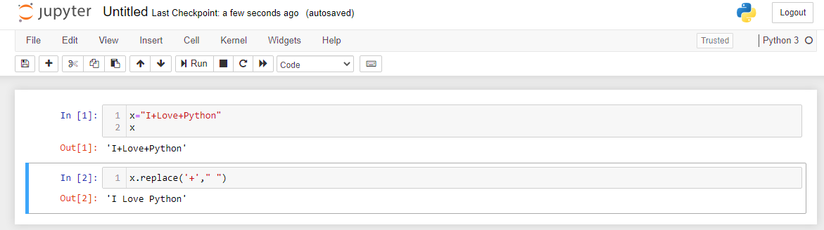

1. What does the function **ord()** do in python? Explain with example. Also, write down the function for getting the datatype of a variable in python.

In python ord() is a function. It accepts single character string and returns the Unicode value of the same. For example, we have a string A if we use ord(‘A’) we will get 65 as output which is the Unicode value of “A”.

type() function is used to get the datatype of a variable in python.in python there are 7 different kind of in built datatypes and they all can be checked by type() function.

Syntax: type(x)

Here x is the variable.

# Q14 and Q15 are programming questions. Answer them in Jupyter Notebook.

1. Write a python program to solve a quadratic equation of the form 𝑎𝑥2 + 𝑏𝑥 + 𝑐 = 0. Where a, b and c are to be taken by user input. Handle the erroneous input, such as ‘a’ should not be equal to 0.

**#NOTEBOOK- QUADRATIC EQUATION**

1. Write a python program to find the sum of first ‘n’ natural numbers without using any loop. Ask user to input the value of ‘n’.

**#NOTEBOOK- SUM OF N NATURAL NUMBERS WITHOUT LOOP**